**Spring 2025**

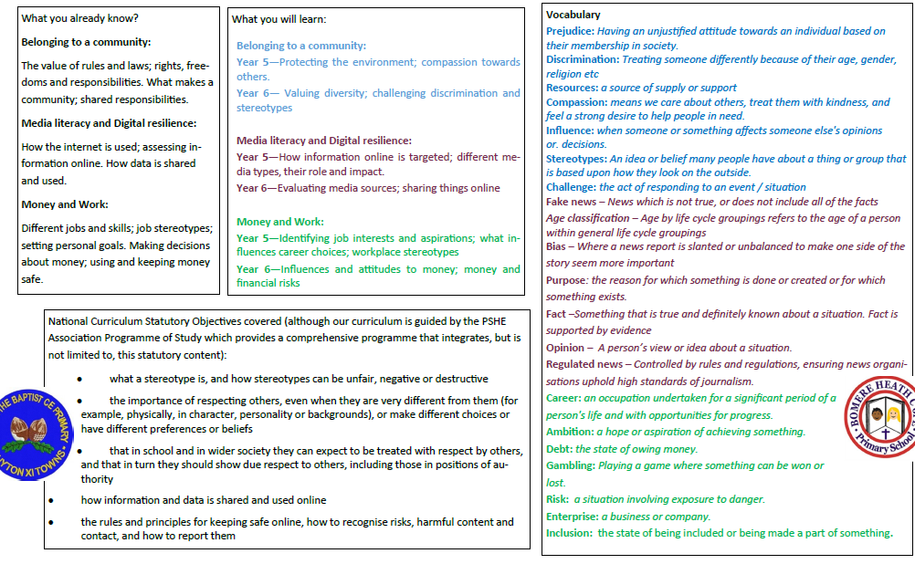

**Living in the Wider World**

**Relationships**