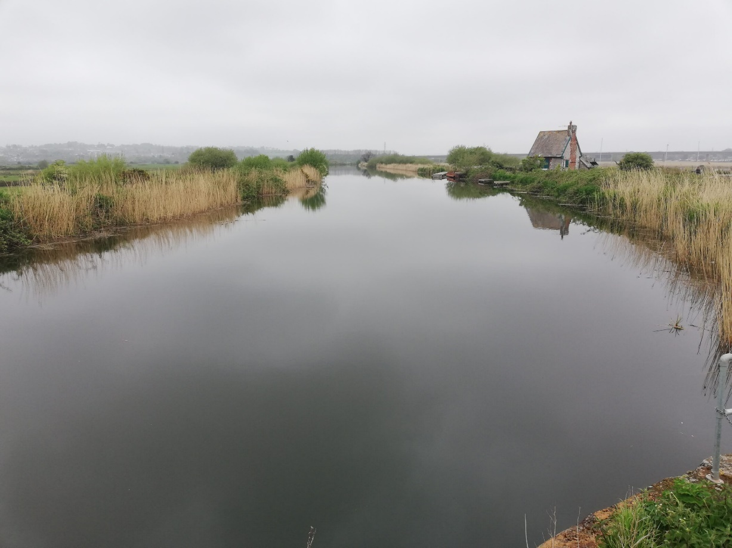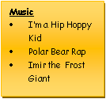

**RE - Why is the Torah so important to Jewish people?**

In Owl class to begin the Spring Term, we will look to answer the question above. This will be carried out by firstly identifying and explaining Jewish beliefs about God, then making clear connections between Jewish beliefs about the Torah and how they use and treat it.

**What difference does the resurrection make for Christians?**

Our 2nd RE unit discusses the idea of resurrection, focusing on the big story of the Bible in Christianity and how the terms resurrection and salvation fit in. We will make connections between the Christian belief in Jesus’ death as a sacrifice and how Christians celebrate Holy

Communion/Lord’s Supper.

beliefs into practice.

**Geography** – **Rivers and Canals**

This term’s topic has a large geography focus. Our learning will focus on both the human and physical geography of rivers and canals, with the addition of understanding the impact of Thomas Telford and the industrial revolution. Children will use maps, atlases, globes and computer mapping to describe key features of the physical aspects of the country. This will include information about rivers and mountains etc. We will also develop an understanding of the human geography of the country, exploring key aspects such as culture, cities and key landmarks.

**History**

Through cross-curricular links, children will learn about Norse gods and mythology in our English unit – Arthur and the Golden Rope. We will also learn lots about the fascinating history of Thomas Telford in our history lessons centred around our rivers and canals topic, which includes a school trip.

**Computing**

Programming - Variables in games

Online Reputation

**PE – Monday & Tuesday**

Knowledge and skills in Physical Education will be developed through NFL Flag, Gymnastics

Tennis / Hi-5 / Dodgeball

**Mathematics** – materials, we will primarily be working on: Multiplication and Division, Fractions, Decimals and Percentages, perimeter and area, statistics during Spring Term, whilst Y6 will begin to understand ratio, algebra and volume. We will develop a fluency in maths skills, applying to varying problems through arithmetic, reasoning and problem solving. Children reason mathematically using knowledge-based language and solve relevant problems. Children will complete regular multiplication tasks so that confidence in times tables is gained; which is encouraged every week through homework tasks too.

**Art & Design & Technology**

• Art - Landscapes (local, photography, creating perspective)

Turner/Frank Lloyd Wright

• DT - Frame Structures

**Music**

**Mrs Kessel-Fell** – Music & KS2 Singing every Wednesday

**Mr Butler** – guitar Friday

**Mrs Nowotarski** - Y5 Violins on Wednesday

**Mr Clowes** – Percussion Y5 & individual Tuesday

**PSHE – Living in the Wider World**

Children learn that in school and in wider society they can be expected to be treated with respect by others, and that they too should show mutual respect. Both year groups learn lots including:

Protecting the environment

Showing compassion towards others

Influences and attitudes towards money and the possible financial risks

**English -** We follow schemes of work from The Literacy Company: Pathways to Read; Write and Spell, to deliver our English curriculum. This term, pupils will develop spoken language skills to give well-structured descriptions and explanations, as well as written skills to enhance the meaning of purpose of their writing. Written tasks will be linked to personal experiences, experiences of others, real events, poetry and the use of role play. This term the pupils will focus on:

* **Writing a myth: to create characters (heroes, villains and monsters) and settings**
* **Writing a narrative poem about a journey across the sea, including personification of the waves.**
* **Writing** **an explanative report (hybrid) about Charles Darwin’s discoveries**

Grammar, punctuation & spellings to be integrated throughout & contextualised, plus handwriting.

*Through reading in particular, pupils will have a chance to develop culturally, emotionally, intellectually, socially and spiritually. A love of reading is promoted & nurtured through s*hared and independent reading.

**Rivers and Canals - Spring 2025**

**Science** – Pupils work scientifically by asking questions, observing systematically, performing practical enquiries, recording, reporting, evaluating and concluding their findings using scientific explanations and evidence which link back to the enquiry focus; analysing the outcomes. Opportunities to gain scientific knowledge and conceptual understanding:

**Light**

Pupils build on their work on light in Year 3 to make more detailed investigations of shadows. They use their conclusions from this work to create shadow puppets and use special effects in their puppet shows. They study reflectivity, build a periscope and investigate the effectiveness of sunglasses, learning about the dangers of UV light.

**Forces**

Pupils learn more about the forces of gravity and friction and investigate the friction of different surfaces. They study air resistance, investigate paper spinners falling, look at floating and sinking and build a self-righting boat. Learning about simple forces includes activities to study pulleys, gears and other simple machines and gives pupils the chance to use their knowledge of machines to build a catapult.