Bomere and the XI Towns Federation

‘With God all things are possible’

Matthew 19:26
Our school nurtures all pupils and those in our school community to flourish as individuals; educationally, spiritually and morally, promoting Christian values through the experience we offer to all. Our core Christian values are Hope, Love and Respect.
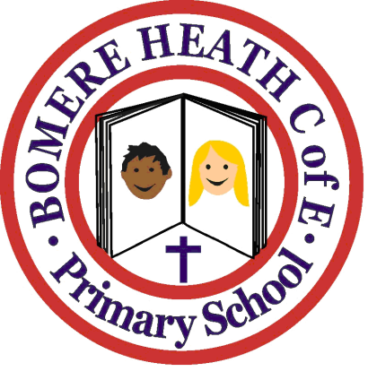

A STATEMENT OF POLICY

British Values

The following policy follows discussion with staff, parents, governors and pupils and should be read in conjunction with other relevant policies and the school prospectus

Date; Autumn 2020
(Original 2016, review 2018 and 2020)

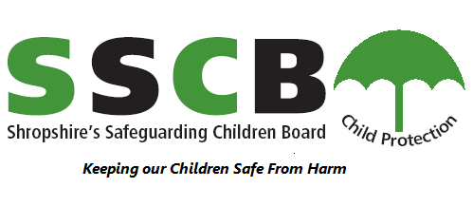
Bomere and the XI Towns Federation
At St. John the Baptist Primary School and Bomere Heath CE Primary School, pupils are expected to learn:
- an understanding of how citizens can influence decision-making through the democratic process
- an understanding that the freedom to hold other faiths and beliefs is protected in law
- an acceptance that people having different faiths or beliefs to oneself, or having none, should be accepted and should not be the cause of prejudicial or discriminatory behavior
- an understanding of the importance of identifying and combatting discrimination and oppression

Promoting British Values
The DfE have recently reinforced the need to ‘create and enforce a clear and rigorous expectation on all schools to promote the fundamental British Values of democracy, the rule of law, individual liberty, mutual respect and the tolerance of those with different faiths and beliefs.’
The Government set out its definition of British Values in the 2011 Prevent Strategy and these values were reiterated in 2014.
At Bomere and the XI Towns Federation these values are modelled and consistently reinforced through our daily worship, through PSHE and Citizenship, and through the ethos of the school.
We are committed to serving our communities and the surrounding areas. We value the diverse ethnic backgrounds of all pupils and their families, and undertake a variety of events and lessons to celebrate these. We have found this approach to be enriching for all parties as it teaches tolerance and respect for the differences in our community and in the wider world.

We encourage admissions from all those entitled to education under British Law regardless of faith, ethnicity, gender, sexuality, political or financial status. We are a school for ALL, and this is reflected on our Mission Statements.

At Bomere and the XI Towns Federation these values are reinforced regularly and in the following ways:
Curriculum:
- In Key Stage 1 pupils are taught about similarities and differences between ways of life in different periods. They also learn about the lives of significant individuals in the past who have contributed to national achievements.
- In Key Stage 2 British and local history is taught. Periods of British history studied include: The Roman Empire and its impact on Britain, Britain’s settlement by the Anglo Saxons and Scots, the Viking and Anglo Saxon struggle for the kingdom of England.
- A World War 2 topic.
- Pupils are involved in Remembrance Day commemorations where children may purchase poppies. A two minute silence is held in a special assembly led by the Head Teacher.
- As a whole school, we have celebrated events of major significance such as Royal Weddings, The Golden Jubilee, the Olympics and Paralympics, and the World Cup.
- Our daily Collective Act of Christian Worship is integral as it is here that we regularly uphold the values of empathy, respect, friendship and tolerance. These values are also taught within formal Social and Cultural Studies (including PSHE and Citizenship) and RE lessons.
- The British values of respect, tolerance and empathy are fostered throughout all of our daily interactions: modelled by staff and nurtured in pupils.

Democracy
- We have School Councils from Reception – Year 6 who meet with the Executive Head Teacher, Deputy Head Teachers and other members of staff regularly to discuss issues and ways to improve the school. Every child on the School Council is voted in by their peers. School Council members wear a badge and have their picture on display to help other children to talk to them about issues.
- We study important democratic events such as General Elections.
- All pupils have been part of reviewing and updating School Rules and Rewards.
- Through our school curriculum children are taught about, and encouraged to respect, public institutions and services.
- Children have an regular opportunities to put forward their views about the school.
- All parents and carers are encouraged to make comments on learning through our open door policy and Parents’ Evenings.

The Rule of Law

- The importance of laws whether they are those that govern the class, the school, or the country, are consistently reinforced at both schools. We consider these as a whole school and in class time regularly.
- Pupils are taught from an early age the rules of the school and are encouraged to reflect on these to help them make good choices. Pupils are taught the value and reasons behind rules and laws, that they govern and protect us, the responsibilities that this involves and the consequences when laws are broken.
- We arrange visits from authorities such as the Police, Ambulance and Fire Service which help reinforce this message.

Individual Liberty

- Pupils are actively encouraged to make choices, knowing that they are in a safe and supportive environment. As a school we educate and provide boundaries for all pupils to make informed choices, through a safe environment and an empowering education.
- Pupils are encouraged to know, understand and exercise their rights and personal freedoms and advised how to exercise these safely, for example through our eSafety and PSHE work.
- We invite agencies, such as the NSPCC, into school to help children make choices to keep themselves safe.
- We have Anti-bullying, Behaviour and Safety Policies in place, which are regularly reviewed, to ensure the Safeguarding of all pupils.

Mutual Respect and Tolerance of those of Different Faiths and Beliefs

- Mutual respect is at the heart of our values. Children learn that their behaviours have an effect on their own rights and those of others. All members of the school community treat each other with respect.
- Both schools are pleased to have a foundation in the values of the Church of England. Jesus taught that we should have love and respect for all beings, including those of different faiths and backgrounds.
- We provide opportunities for the children to visit places of significant cultural interest and religious places, such as St. John the Baptist Church, Holy Trinity Church, the Baptist Church and Synagogues, Mosques and Temples.
- We support a range of charities (such as UNICEF, Comic Relief, NSPCC, Hope House) and plan fundraising and awareness raising activities to support those charities.
- Members of different faiths, and of none, are encouraged to share their knowledge to enhance learning

What are we planning in the future?
- Increasing visits to both schools from members of other communities, faiths and religions, and those of no religion.
- Increasing school visits to a wider range of places of worship

Also see: Promoting British Values - gov.uk

