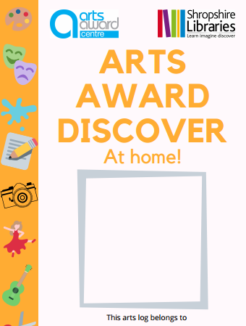

Max Clifton-Moore
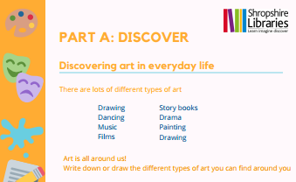

- Pottery – we have a vase which is thrown on a wheel and a vase which has been hand built from coils
- A screen-printed picture of a puffin
- Sculptures made out of Lego
- Photography – we have some photographs of nature
- A wood carving of an owl
- A drawing by the ‘Constant Doodler’ who creates pictures where he doesn’t take his pen of the page at all, until the drawing is completed
- A metal wall hanging in the shape of a swirl
- Lots of my drawings and paintings!

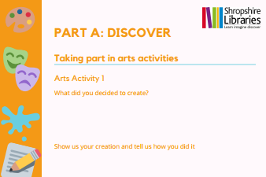

I created a painting using gouache paints on a canvas. I mixed the colours in a palette to create lots of calming colours. I used a dabber to create lots of dots. These represent all of the people who want to be together in lockdown but who have to be separate at the moment.
I liked the colours which I mixed together and they looked a bit like the colour of peacock feathers using blues and greens. I had to let the different colours dry in between layers and gradually fill up the whole canvas. At first I thought I would leave some white gaps but as I worked on the painting, I decided that it looked better to fill the whole canvas with colour.
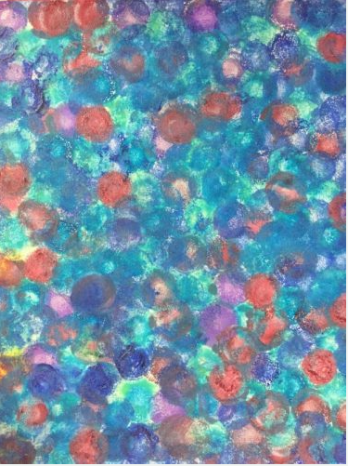
Here is my painting displayed on the mantlepiece at home:
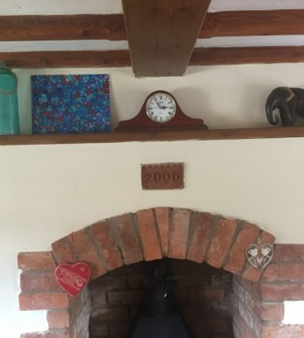
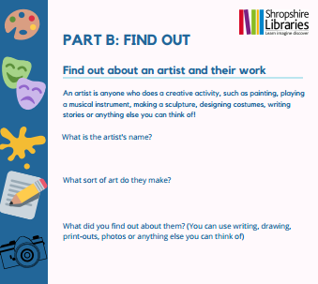

Artist’s name: Bridget Riley, born in 1931
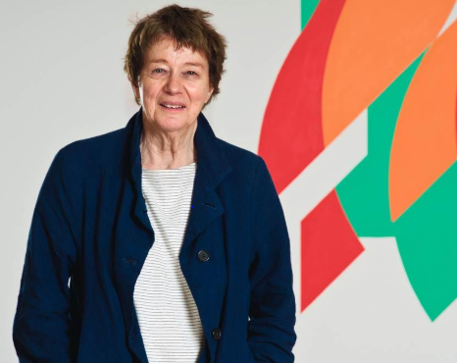

What sort of art does she make?
She makes pictures which look like they are moving. Some of the paintings with squiggly lines look like they are 3D. She often uses straight lines, circles, triangles and squares to make patterns. Here are some examples of her work:

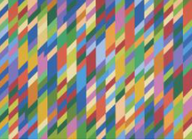

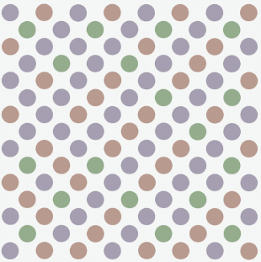

What did you find out about them?
She studied art at Goldsmiths College (1949 – 52) and then at the Royal College of Art (1952-55).
She taught art to children between 1957 and 1958.
She was influenced by a French painter called Seurat. Here is an example of his work:
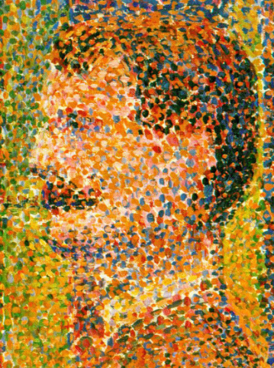
She carefully plans hers works using drawings and collages. She then gets her assistants in her studio to create the final work, whilst she supervises them.
She likes to explore colours and how they work with each other.

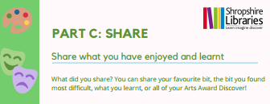
I shared my painting with my family by sending them a photograph of my painting. I explained how I had made my painting by building up layers of colour using a dabber. My cousin was really interested in how I had done this and I sent a photograph to her of my special dabber brush so that she could order one too!
My auntie commented on the photograph of my painting: ‘Wow Max! I love the colours you have used.’
I also shared a photograph of my painting with my brother’s Godmother who used to be a curator in an art gallery. She said that my painting reminded her of some of Bridget Riley’s paintings. This then led me onto doing some research into Riley’s paintings.

I also shared my art with my teacher and my class at school. Although we can’t go to school at the moment, my painting was shared on the school website so that my classmates could see it. Here is the message from my teacher about my painting:
