Boy Tries To Poison his Crabby Grandma
A boy named George tried to kill his grandma by tricking her into drinking a concoction of things he had mixed.
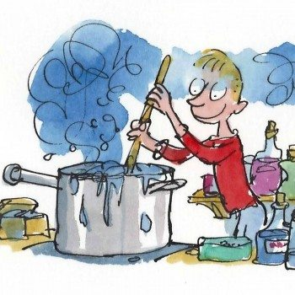
Two days ago, Netty Field was on her daily walk through the local fields looking for birds with her binoculars. As she climbed over the style to the next field, she heard shouting “George its time for my medicine.” She pulled out her binoculars to see were the voice was coming from. They wee coming from the farmyard cottage. “Not yet Grandma there’s still twenty minutes to eleven.” “What are you up to now.” Netty saw through her binoculars a boy stirring a thick, chunky, green liquid. It began to froth and foam and a rich blue smoke the colour of a peacock’s feathers entered the air a dreadful smell whoofed through the window right at netty the smell smelt spicy and staggering fierce and frenzied. After that terrible thing she saw the poor lady dialled the police and explained what happened.

