Story starter! 16/4/20
When the dragon had hatched, crawling out of its shell onto her bed, Zoya knew that her life would never be the same again.
She had brought the dragon far away from her village; away from the people who would hurt it and take it away from her. As she held it in her hands, feeling its claws affectionately digging into her fingers through her gloves, Zoya knew that exactly what she had to do. What they had to do. Together.
The dragon gazed at her. She could see the flames burning within its eyes. It was totally dependant on her, as a new-born child is to its mother. And yet, strangely, she felt dependant upon the dragon as well; dependant upon what it was and what it would become in time.
They would become inseparable. Their futures were entwined. Their adventures were only just beginning… Zoya began to wonder how she was going to look after this most miraculous creature alone? As it was just a baby, could she teach it to fend for its self or to protect her from danger? both were hard decisions but Zoya knew the most important thing was to train him to fend for himself, to be prepared for anything that could happen to him in the future.
Training started the next day, at sun rise, being able to train a dragon on the first go was almost impossible, you had to be persistent and you had to be able to have fun. On first go Zoya tried to make him breathe fire on command, he instantly thought it was a game and created a bush fire. Zoya was surprised by the amount of fire coming out a baby dragons mouth. Running away from the aggressive, steaming hot fire she looked behind her for the dragon, checking he was safe she noticed that the fire had vanished, then she saw her loved dragon putting out the fire by breathing water like a fire extinguisher but this was very strange because dragons that existed then only have one power, unless the legend was incorrect. This dragon must have been one of the dragons that have survived but that means there might be more. Another legend says there is a hidden temple hidden in a cavern in the Snowy Mountain range where there is a barrier that dragons can only pass though.
Completely forgetting about training Zoya and newly named Flame set of trying to find the Snowy Mountain range with only a compass every once in a while a lake or a river would be near their path and they would catch fish to cook them on a fire since ,Flame can breathe fire,. Since Flame was a beast, that could a horse, he would lie in the water open mouthed and would wait until fish would swim in then he would smack his mouth closed open his gills so the water would run out and would eat the fish.
Along the long and tiring journey there were now very few pond, lakes or rivers ones that were spotted were ice-covered and the ice was too thick even for Flame to melt. Two days later Zoya saw people in the distance but they seemed to be charging towards them with pitchforks and lit torches Zoya told Flame to fly up as high as he can but he could only fly as high as a single mans arm, flying back down Zoya shoved Flame in her backpack and stood the as still as a statue and waited until they were close enough to grab her but her bag sent out a tsunami and washed everyone including Zoya to their village witch was what felt like a mile away.
As soon as Zoya’s feet touched the ground she ran as fast as she could, unfortunately they were faster than her and caught her and took her back to their village to be interrogated by their leader but as quick as a flash Flame lit a flame on the leaders hut as a distraction when the villagers let go to make sure no one was inside, they ran as far away as they could and as soon as they were out of sight the fire disappeared.
Soon the path was hidden beneath a blanket of pure white snow Zoya new they were near to the mountains nevertheless the sky was full of snow; it was impossible to see through. They kept walking having little hope left inside them but… as if their wish came true a wide range of mountains spread out before them as if showing themselves from the darkness. Zoya put Flame in her backpack and started climbing the face of the mountain to a high up large hole in one of the mountains. As she reach the hole she saw five pillars standing tall so the mountain doesn’t cave in she picked up Flame from her bag and placed him on her shoulders and walked to enter she didn’t get forced out since the dragon on her shoulders could enter…
In the obese room there was bioluminescent plants reaching to the roof of the cavern and large flowers with lots of pollen in to feed different sorts of dragon, platforms were spread out and there was a single tree larger than any other full of nests and baby dragons the adult dragons were about the size of sixty busses in length and twenty busses in hight. The baby dragons were flying around in cluster and Zoya was amazed and surprised by their speed, agility and colours their colours shone like the rainbow… 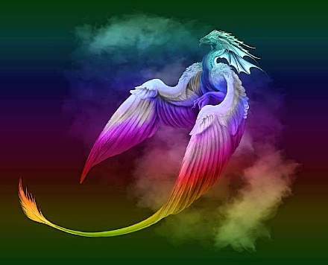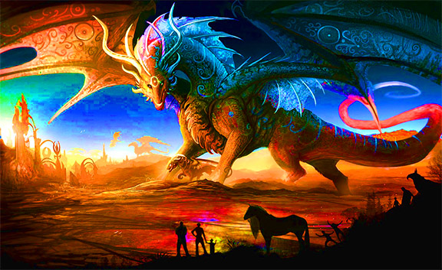
This Photo by Unknown Author is licensed under CC BY-NC-ND

